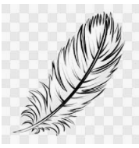
10 Rhyme Road Bedtimesville

Friday 18th February 2022

Dear Year One,

I have heard that you have been writing letters, just like mine, to help characters from nursery rhymes. Do you think you could you help me?
All day long, I read and write letters to help all of my friends. I would like to do something different. Maybe a hobby would be nice. Please could you give me some ideas of things that I could do so I can have a break?
I look forward to reading your ideas.
Thank you.
From
Mother Goose

