Mind the Gap!
You need: Squared paper or an empty grid, two different colour pens, a ruler and two dice

Before you start:
- Choose a pen each.
- Decide who will go first.

Take turns to:
- Roll the dice and draw a rectangle on the grid with the number of rows and columns to match the numbers on the dice. For example if you roll a 2 and a 3 then draw a rectangle that is made of 2 rows of 3 squares.
- Write the number of squares your rectangle covers inside the rectangle.
- If you cannot fit your rectangle in you miss a go.
- When it is not possible to fit any more rectangles on, each player adds up the number of squares covered by their rectangles.

Winner
- The person with the biggest total wins!
8
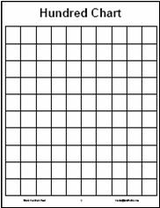
15
For example:
Brian throws 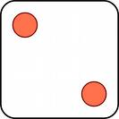 and 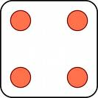 , draws the red rectangle and writes 8 inside it.
George throws 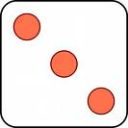 and 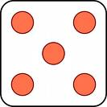 , draws the blue rectangle and writes 15 inside it.

It is now Brian’s go again.
Here are some blank grids for your games:
Ideas for changing the rules to vary the game:
- Change the size of the grid or the dice used.
- Play with more than two players or give each player their own grid and try to be the first to complete it.
- Allow players to split their rectangles into two so that they can fit them on
- Or…

